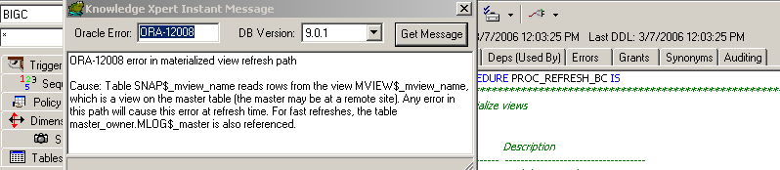

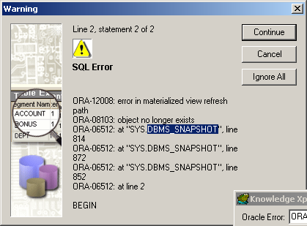

PROCEDURE USED:

CREATE OR REPLACE PROCEDURE PROC_REFRESH_BC IS

BEGIN
DBMS_MVIEW.REFRESH('STORE_DIM'); -- Store Dimension
DBMS_MVIEW.REFRESH('BUSINESS_DIM_OU'); -- Support Business dimension
DBMS_MVIEW.REFRESH('BUSINESS_DIM'); -- Business Dimension
DBMS_MVIEW.REFRESH('BC_FACT'); -- Summarized Income,Area,Budget Data by Dimensions

END PROC_REFRESH_BC;
/

